1. Type the URL: <http://www.oracle.com/technetwork/java/javase/downloads/jdk7-downloads-1880260.html>

2. Click on "Accept Licence Agreement" and click on the Download link specific to your **Operating System**

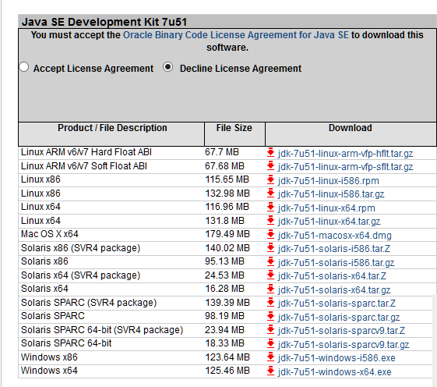

To Write the code in Eclipse: <http://www.eclipse.org/downloads/>

1. Download the Eclispe from link

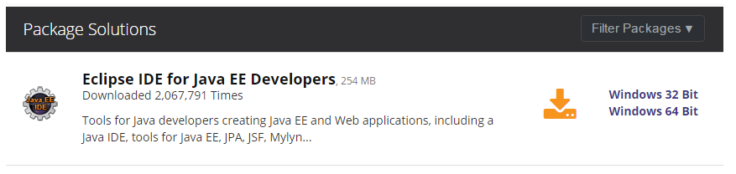

1. Install the Eclipse on your local. Please choose the installer based on your OS.
2. Follow the WIZARD to complete the installation.
3. A shortcut will be on your local or go to the eclipse folder and you can see Eclipse.exe icon 
4. Double click on eclipse.exe which will open the dialog box as below – Enter the folder location where you have to save the code. In this case I have entered d:\Java\Demo and click on OK button  
   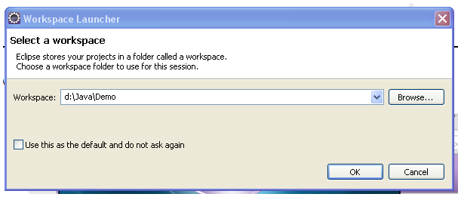
5. You will be taken inside eclipse. There Create a new Java Project by
   1. Click on File->New->Project->Select Java Project->Click in Next->Enter the project name and click on ‘Finish’

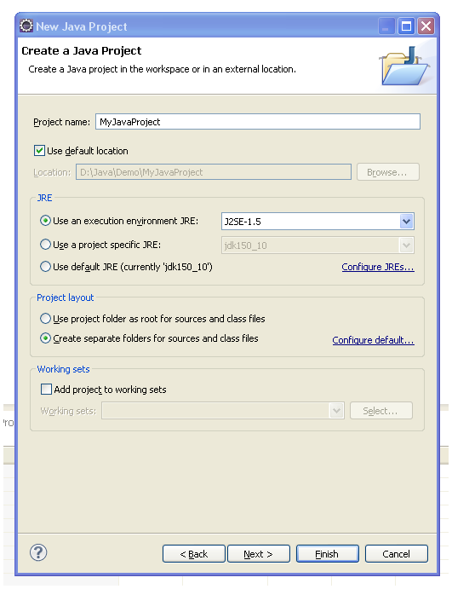

1. You will see a Java Project as below

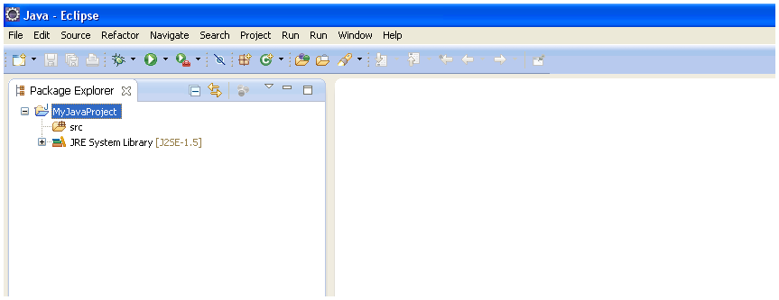

1. Right click on ‘Src’ (Shown in above screen), Select New->Class.
2. Give a file name and the Java class gets created. Type the Java Code there and then save.
3. Also, before you complie check if JSD is setup in your eclipse. Follow below steps
   1. Click on Menu Window->Prefrences->Expand Java-> Select Installed JRE’s
   2. If you don’t see jDK selected there, click on Add button and select your JDK folder

